Plant Systematics Laboratory #17
Plant COLLECTING AND DOCUMENTATION

OBJECTIVES FOR THIS LABORATORY:
1. Review the basics of plant collecting.
2. Practice documenting information taken at the time of collecting.

Plant Collecting and Documentation
With a partner, review the proper procedure for collecting plants. Have your partner correct or add to what you recite.

Study the documentation information that should be recorded at the time of a plant collection. Next, with a partner, try to recite as much of this information as you can; have your partner correct or add to what you recite.

During class, go outside and collect both an herb (digging up the entire plants) and a woody shrub or tree. While outside, fill out (for one species only) as much as you can of the documentation sheet(s) on the next pages.

Store the two plants collected, as if you were going to keep them for some time before processing them.

Press the two plants collected above in an herbarium press and dry them in a plant drier.

Plant Mapping
Examine available topographic maps. Practice locating yourself on the map, using various landmarks.

Calculate the latitude and longitude of your location for inclusion in the documentation information.

Calculate the latitude and longitude of another specified location. Compare this with those obtained by the rest of the class.

Plant Community Classification, Identification, and Mapping
(contributed by Robert Lauri)
Plant communities are classified according to structure of canopy, or type, (tree, shrub, or herbaceous) and dominance of taxa. There are a number of common sub-classifications of plant communities within the California Floristic Province. These sub-classifications include, (forest, chaparral, riparian, and sage scrub, etc.), which are further divided into more specific classifications. These more specific classifications are referred to as series and are based on the dominant tree, shrub, or herb in that canopy. The name given to each series is often the common name of the dominant and co-dominant taxa coupled with the sub-classification type. Examples of these within the California Floristic Province are coast live oak woodland, chamise chaparral, white sage scrub, and white alder riparian.

Identifying plant communities can be a very difficult task, especially for the novice. It is common for plant communities to intergrade with one another and have no distinct boundaries. For this reason, it is common practice to identify and map plant communities is many stages. The first stage is to identify plant community canopy types in the field using visual inspection. Each plant community should then be rapidly mapped onto a USGS topography map, using an aerial photograph of the area to assist with the determination of tree versus shrub and herbaceous canopies. This first attempt at mapping the plant communities should be a rough estimate of the locations of each community, and then including identification of each community by visually assessing the dominance of the taxa. The next step in identification of the plant communities is to perform a more thorough evaluation of each by field inspecting them and recording habitat data using the California Native Plant Society (CNPS) Rapid Assessment method, Figure 1. This method allows the botanist to record the plant community and habitat data rapidly i.e. (location, latitude, longitude, history, soil type, dominance of each canopy type etc.) Once the rapid assessment has been completed the data can be compared with the initial field inspection data and revised accordingly. The revised identifications of the plant communities should be updated at this time to reflect the dominance and co-dominance of the taxa found during the rapid assessment. After the identifications have been revised, a final field inspection should be made to ensure that the mapping of the plant communities reflect the plant classification and identification revisions.

Plant community identification and mapping within government agencies and environmental consultants often ends with the rapid assessment method or similar methodology. However, I have found that the more in depth methods that include plant community transects (using belt and quadrangle) can provide more accurate and quantifiable taxa diversity and dominance data. Once the plant community habitats have been assessed, transects can be laid out in representative communities of each series. A minimum of ten transects should be run for each series with twelve data points collected for each belt transect, and four data points collected for each quadrant transect. All transect points are marked in the field with permanent rebar markers, or temporary construction nail markers. Two markers should be used for belt transects and one should be used for quadrant transects. The latitude, longitude, and elevation of the transect line can then be recorded using a GPS unit. Quadrant transects are taken by using a frame (wood or PVC) that is one meter square and split into four equal quadrants (Figure 2). This method is often used for dense herbaceous plant communities near ponds and streams. The transect frame is laid on the ground or over short vegetation, with the taxa then being identified and the coverage of each taxon recorded similar to the belt transects described below. There should be only one or two canopies identified using the quadrant method. For communities with three canopies, the belt transect is the preferred method. Belt transects should be between 50 and 100 meters long in order to collect the desired number of data points. Additional Belt transects may be necessary if twelve data points can not be made for the individual transect. For Belt transects, a 100-meter tape measure is used to span the appropriate distance within the plant community between two points, (Figure 3). Approximately twelve, one meter squares should then chosen at random along the transect starting at the zero mark. The one-meter square can also be chosen by taking data points at 5-meter intervals. Once the data point has been chosen a meter stick, or a one-meter square frame can be used to temporarily delimit the area. The taxa that are contained within the data point can then be identified and listed on the data sheet (Figure 4), shortening the taxa name to six letters to reflect the full species name (the first three letters of the genus and specific epithet). After the taxa have been identified, the number of square centimeters of coverage of each taxon, bare soil, rock, and leaf litter should be estimated using the meter stick, and recorded. This should be accomplished by ensuring that the taxa considered are placed into a canopy layer that is considered 100 percent occupied. For the tree canopy there is either open sky, (zero percent canopy), or some percentage of tree cover. For the shrub canopy there are either no shrubs, or a percentage of shrub cover. For the herbaceous canopy there is either bare soil, rock, leaf litter, or some percentage of herbaceous cover. Once the data has been recorded for all the data points for that particular plant community, the data can be combined onto a master data sheet (Figure 5) to quantify the dominant and co-dominant taxa for each series and plant community. Once all the data has been combined for each plant community, the community can then be reassessed to ensure the proper identification and classification has been made. This information should then be updated on the plant community map, along with the locations of the transects taken.

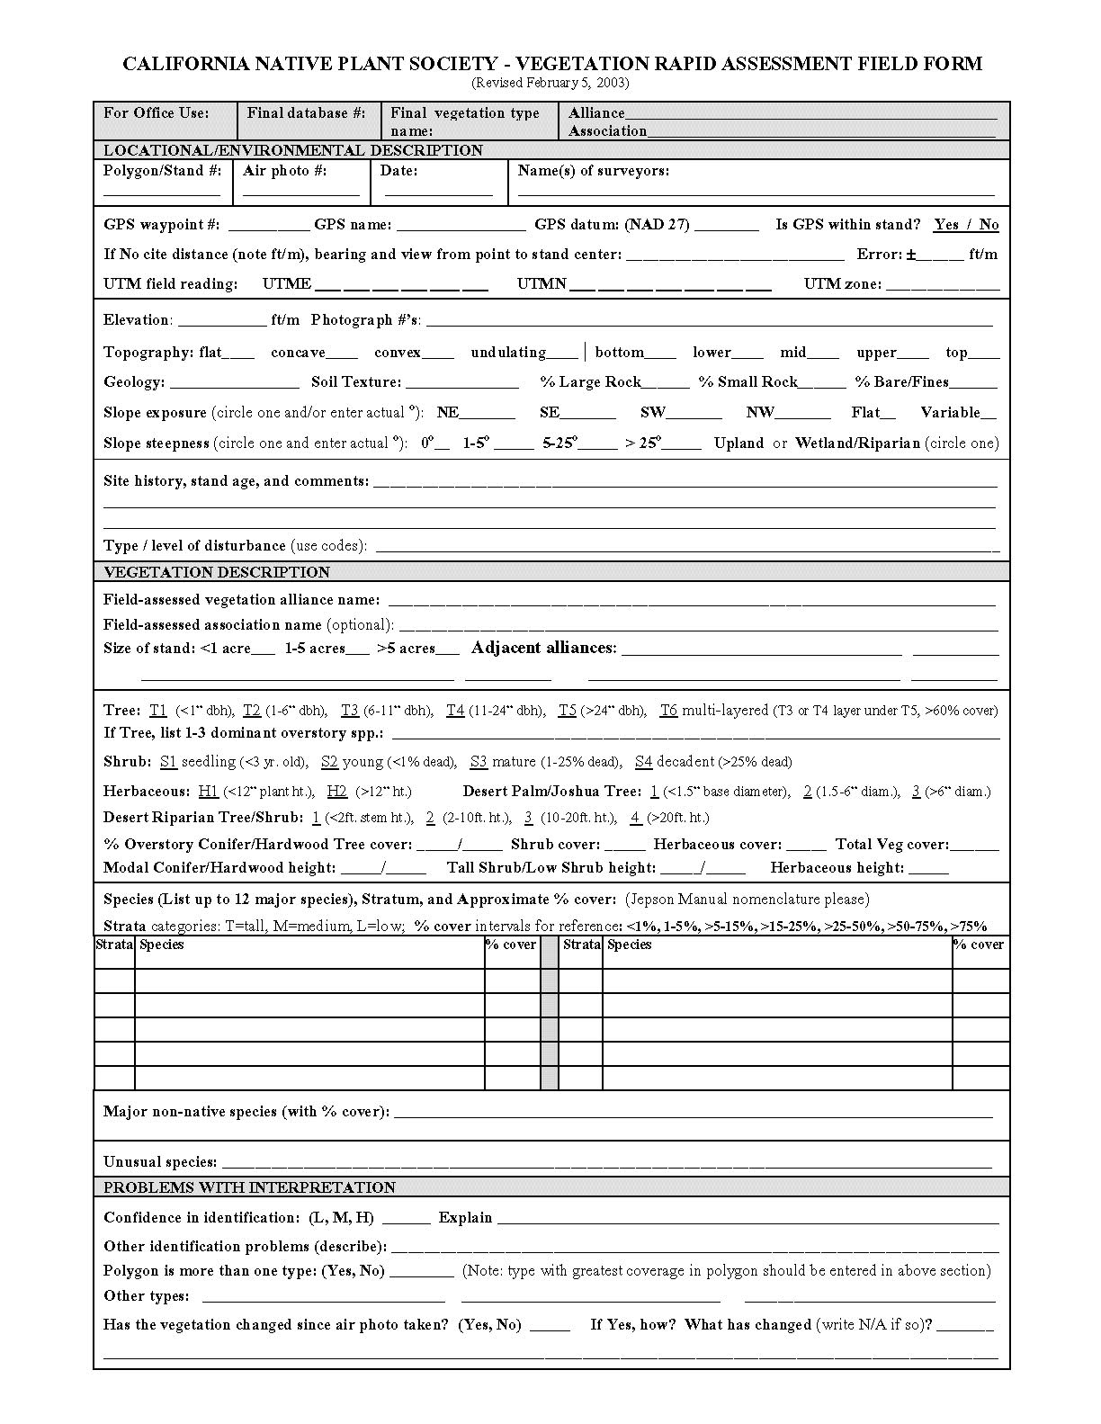Figure 1 California Native Plant Society Rapid Assessment Form

Figure 2 Quadrant Transect

Figure3 Belt Transect

Taxon | 0 m | 5 m | 10 m | 15 m | 20 m | 25 m | 30 m | 35 m | 40 m | 45 m | 50 m | 55 m | 60 m | 65 m | 70 m | 75 m | 80 m | 85 m | 90m | 95m | 100m | Total
Open ground
Total taxa
Total chars.
Tree Layer
Shrub Layer
Ground Layer

Figure 4 Example Transect Data Sheet
Montane Meadow | Transect | Transect | Transect | Transect | Transect | Transect | Transect | Transect | Transect | Transect
 | M1 | M3 | M4 | M5 | M6 | M7 | M8 | M9 | M10 | M11 | Totals | Percent
Epibra | 10 |  |  | 10 | 40 |  |  |  |  |  | 60 | 1%G
Brotec | 170 | 320 | 70 | 200 | 190 |  |  |  |  |  | 950 | 16%G
Car | 690 |  |  |  |  |  |  |  |  |  | 690 | 11%G
Erigra | 20 |  |  |  |  |  |  |  |  |  | 20 | 0.2%G
Mulrig | 20 |  |  |  | 90 |  |  |  |  |  | 110 | 2%G
Sisiri | 20 | 20 |  |  |  |  |  |  |  |  | 40 | 0.5%G
Artdra | 0.0E+01 | 160 | 130 | 0.0E+01 | 0.0E+01 |  |  |  |  |  | 290 | 100%S
Astooc |  | 90 |  | 90 | 60 |  |  |  |  |  | 240 | 4%G
Elisp |  | 290 |  |  |  |  |  |  |  |  | 290 | 5%G
Lepvir |  | 50 |  |  |  |  |  |  |  |  | 50 | 1%G
Leytri |  | 180 | 170 |  | 10 |  |  |  |  |  | 360 | 6%G
Achmil |  | 90 | 80 |  | 10 |  |  |  |  |  | 180 | 3%G
Solcal |  |  | 30 |  |  |  |  |  |  |  | 30 | 0.4%G
Cirsca |  |  | 80 |  |  |  |  |  |  |  | 80 | 1%G
Brodia |  |  | 60 |  |  |  |  |  |  |  | 60 | 1%G
Junmex |  |  | 560 |  | 280 |  |  |  |  |  | 840 | 14%G
Pteraqu |  |  |  | 720 | 190 |  |  |  |  |  | 910 | 15%G
Erimol |  |  |  | 90 | 10 |  |  |  |  |  | 100 | 2%G
Chacyc |  |  |  | 30 |  |  |  |  |  |  | 30 | 0.5%G
Elisp |  |  |  |  | 50 |  |  |  |  |  | 50 | 1%G
Poa |  |  |  |  | 10 |  |  |  |  |  | 10 | 0.1%G
Hypfor |  |  |  |  | 60 |  |  |  |  |  | 60 | 1%G
Vulmyr |  |  |  |  | 100 |  |  |  |  |  | 100 | 2%G
Placol |  |  |  |  | 30 |  |  |  |  |  | 30 | 0.4%G
 |  |  |  |  |  |  |  |  |  |  | 0.0E+01
Open ground | 170 | 100 | 120 | 180 | 180 |  |  |  |  |  | 750 | 12%G
Total Taxa | 24
Total Characters | 25
Tree Layer | 0.0E+01
Shrub Layer | 290
Ground Layer | 6040

Figure 5 Example Master Data Sheet

